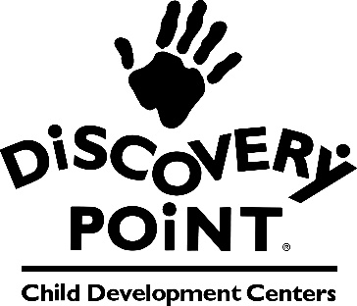

Dear Parents,

The health and safety of our children, families and staff is of the utmost importance to us. Therefore, we wanted to let you know that we have a confirmed case of COVID-19 in your child’s class.

At this time, your child does not need to quarantine, however, we ask that you carefully monitor your child’s health for any symptoms including the following:

* Fever (over 100.4) or chills
* cough
* shortness of breath or difficulty breathing
* fatigue
* muscle or body aches
* headache
* new loss of taste or smell
* sore throat
* congestion or runny nose
* nausea or vomiting
* diarrhea

If your child begins to exhibit symptoms or is diagnosed with COVID-19, we ask that you please notify the center. Your child may return to school when there have been at least 5 days since the onset of symptoms, and they have been fever free for 24 hours without the aid of medication. If your child begins to exhibit symptoms while at the center, you will be contacted to pick them up.

As always, we are taking every precaution to prevent the spread of illness at our school, including additional sanitation procedures. We will continue to strictly enforce our handwashing policy, which includes anyone entering the classroom for any reason and practice physical distancing when possible.

Please note that guidance may change based on community levels. For more information on COVID-19 in your county please visit <https://www.cdc.gov/coronavirus/2019-ncov/your-health/covid-by-county.html>

If you have any questions or concerns, please do not hesitate to let us know. We thank you for your cooperation and your continued confidence in our Discovery Point center.

Sincerely,

Discovery Point Management